DEVOPS LAB

COMMON PREREQUISITE INSTALLATIONS
Pre-requisite Software Installation
Install JDK
sudo apt install openjdk-11-jdk
- Verify Java
java --version
- Install Git
sudo apt install git
- Verify Git
git --version
- Install Maven
sudo apt install maven
- Verify Maven
mvn --version
- Install Gradle
sudo apt install gradle
- Verify Gradle
gradle -v
- Install Ansible
sudo apt install ansible
- Verify Ansible
ansible --version
- Download Chrome
wget https://dl.google.com/linux/direct/google-chrome-stable_current_amd64.deb
- Install Chrome
sudo dpkg -i google-chrome-stable_current_amd64.deb
- Verify Chrome
google-chrome --version
- Download Jenkins:Automation Server from App Store
- Open Chrome and Run
https://localhost:8080/

Program 1: Working with Maven – Creating a Maven Project, Understanding the POM File
Procedure
Step 1: Create a Maven Project
Open the terminal and run the following command:
mvn archetype:generate -DgroupId=com.example -DartifactId=MyMavenApp \
-DarchetypeArtifactId=maven-archetype-quickstart -DinteractiveMode=false
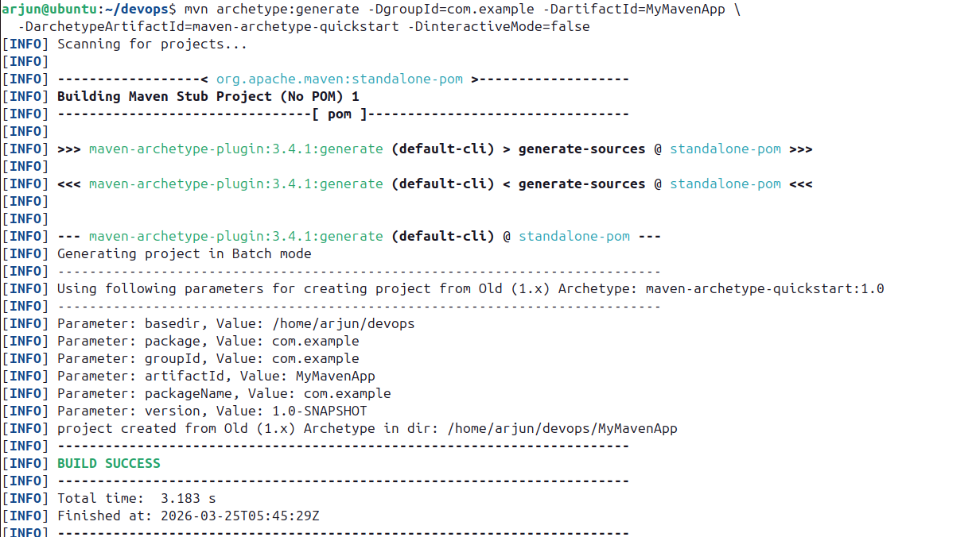

Step 2: Navigate to the Project Directory
cd MyMavenApp
tree
The generated directory structure is as follows:
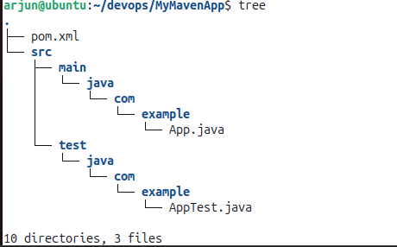

Step 3: Open and Edit pom.xml
gedit pom.xml

pom.xml
<project xmlns="http://maven.apache.org/POM/4.0.0"
xmlns:xsi="http://www.w3.org/2001/XMLSchema-instance"
xsi:schemaLocation="http://maven.apache.org/POM/4.0.0
http://maven.apache.org/maven-v4_0_0.xsd">
<modelVersion>4.0.0</modelVersion>
<groupId>com.example</groupId>
<artifactId>MyMavenApp</artifactId>
<packaging>jar</packaging>
<version>1.0-SNAPSHOT</version>
<name>MyMavenApp</name>
<url>http://maven.apache.org</url>
<properties>
<maven.compiler.source>11</maven.compiler.source>
<maven.compiler.target>11</maven.compiler.target>
</properties>
<dependencies>
<dependency>
<groupId>junit</groupId>
<artifactId>junit</artifactId>
<version>3.8.1</version>
<scope>test</scope>
</dependency>
</dependencies>
<build>
<plugins>
<plugin>
<groupId>org.apache.maven.plugins</groupId>
<artifactId>maven-compiler-plugin</artifactId>
<version>3.8.1</version>
<configuration>
<source>1.7</source>
<target>1.7</target>
</configuration>
</plugin>
<plugin>
<groupId>org.apache.maven.plugins</groupId>
<artifactId>maven-surefire-plugin</artifactId>
<version>2.22.2</version>
</plugin>
<plugin>
<groupId>org.apache.maven.plugins</groupId>
<artifactId>maven-jar-plugin</artifactId>
<version>3.1.0</version>
<configuration>
<archive>
<manifestEntries>
<Main-Class>com.example.MainClass</Main-Class>
</manifestEntries>
</archive>
</configuration>
</plugin>
</plugins>
</build>
</project>

Go to https://mvnrepository.com, search for junit, select the required version and copy the dependency XML snippet. Paste it under the <dependencies> section. Also add the maven-compiler-plugin, maven-surefire-plugin, and maven-jar-plugin under the <build> section.

Step 4: Create MainClass.java
cd src/main/java/com/example/
gedit MainClass.java

MainClass.java
package com.example;

public class MainClass {
public static void main(String[] args) {
System.out.println("Hello Devops");
}
}
Step 5: Compile the Project
mvn compile
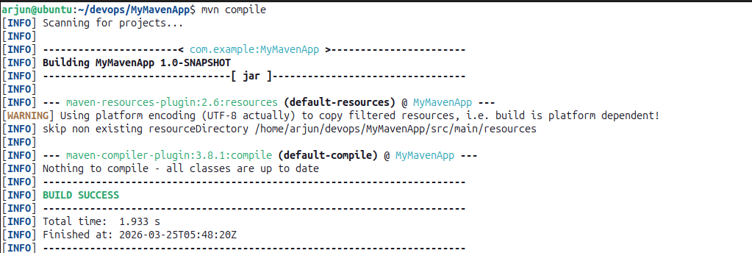

Step 6: Package the Project
mvn package
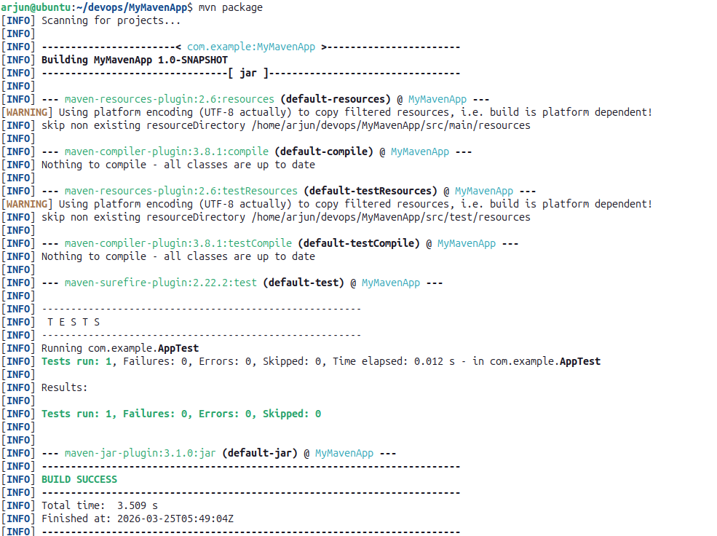
This creates MyMavenApp-1.0-SNAPSHOT.jar inside the target/ folder.

Step 7: Run the Tests
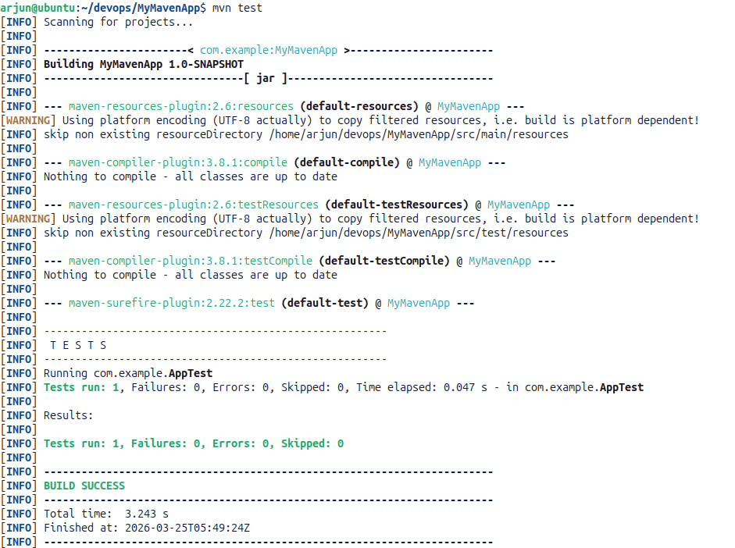
mvn test

Step 8: Run the Application
cd target
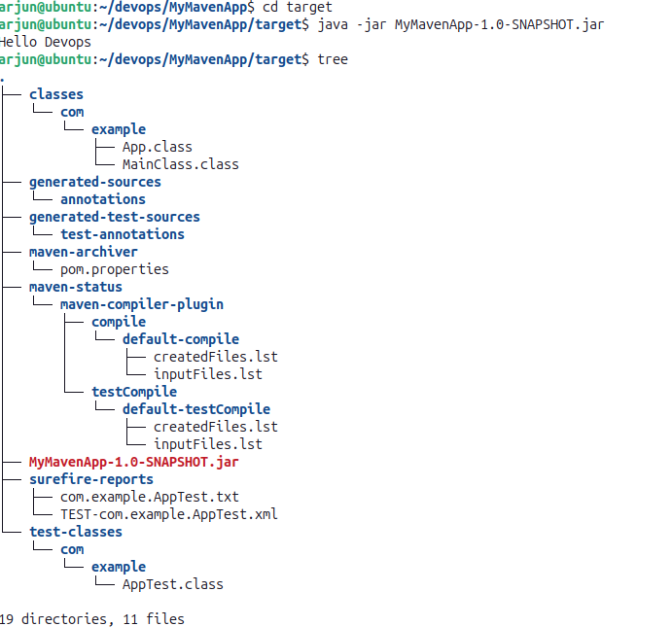
java -jar MyMavenApp-1.0-SNAPSHOT.jar

